**Ministry of Health of Ukraine**

**I. HORBACHEVSKY TERNOPIL NATIONAL MEDICAL UNIVERSITY**

**of the Ministry of Health of Ukraine**

**Ternopil Regional Scientific Society of Pathophysiologists**

**XIV Scientific and practical conference**

**"Actual issues of pathology**

**under conditions of action of extraordinary factors on the body"**

**October 23-25 2024**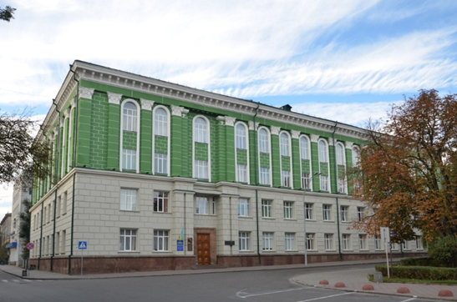

**INVITATION**

**DEAR COLLEAGUES!**

We have the honor to invite you to take part in the 14th scientific and practical conference "**Actual issues of pathology in the conditions of action on the body of extraordinary factors**", which will be held on **October 23-25, 2024** at the I. Horbachevsky Ternopil National medical university of the Ministry of Health of Ukraine.

**Scientific and practical directions of the conference:**

1. Problems of the pathology of the cardiovascular system.

2. Neurohumoral regulation of the body in pathology. Immunocytokinogenesis in pathology.

3. Metabolic changes due to extreme effects on the body.

4. Pathophysiology of extreme conditions and stress.

***To participate in the conference, it is necessary to fill out the questionnaire for each of the authors by September 30, 2024 at the link:*** [<https://t.ly/5hUrt>](https://t.ly/5hUrt) ***and send theses for publication in the conference materials to*** APPkonf@gmail.com***.***

**Requirements for scientific materials submitted to the conference**

Abstracts are drawn up in the Microsoft Word editor and saved in rtf format. The volume of theses is 1800-3600 printed characters, Times New Roman font 14 pt, alignment - widthwise for the main text and centered - for the title (highlighted in bold).

The first paragraph indicates the surnames and initials of the authors, the second - the title of the thesis (all letters are capitalized for the title), the third - the name of the organization in which the work was performed, the city, the fourth - the main text of the thesis. These must be signed by all authors and Plow details of one of the authors (e-mail - mandatory, address, phone). The file with theses is called the name of the 1st author + the first word of the name of the thesis (in Latin). The conference proceedings will be sent to the e-mail address of the authors in the form of a PDF file. In addition to the electronic version (in PDF format), it will be posted on the website: http://tontpu.co.ua. These are not editable. The authors are not responsible for the accuracy of the given information.

The cost of publication is UAH 150. for 1800 printed characters (with spaces). The publication price includes the conference proceedings as a PDF file and a certificate for the first author, which will be sent as a PDF file.

**CONFERENCE PROGRAM**

|  |  |
| --- | --- |
| October 23, 2024  Registration of participants | |
|  | |
| |  |  | | --- | --- | | 1100-1130 | Opening of the conference | | 1130-1300 | Plenary session | | 1300-1400 | Lunch break | | 1400-1800 | Section meetings |   October 24, 2024 | |
| 1000-1800 | Section meetings |
| 1300-1400 | Lunch break |
|  | Start of testing |
| October 25, 2024 | |
| 1000-1300 | Section meetings |
| 1300-1400 | Lunch break |
| 1400-1500 | Summary of the conference.  Closing the conference  Завершення тестування |
|  |  |
|  |  |
|  | |